**PROJECT PROPOSAL**

**OPPORTUNITY**

**VISION**

**Product Goal**

Create a web application that combines a travel log, blog and photo sharing socal network such as Instagram into one. Not only will this be a social network for travelers, users will also have the opportunity to customize their profiles with

**Stakeholders**

Travel bloggers, students and professions who travel frequently will have a space to store all of their experiences as well as interact with others who have made similar trip.

**Competitors**

The following table shows our biggest competitors:

|  |  |  |  |
| --- | --- | --- | --- |
|  | **Our Product** | **Bonjournal -** [**https://bonjourn.al/**](https://bonjourn.al/) | **Journi -** [**https://www.journiapp.com/**](https://www.journiapp.com/) |
| Customization available? | Yes | No. Very formulaic page, although beautiful. | No, formulaic and less beautiful/clean |
| Connect with other people through the application | Yes. There will be a chat site with different channels that people can join depending on what they want to talk about | No. can only view public profiles. | No. can only view public profiles. |
| Concept of collectibles | Yes | No. | No. |
| Mobile Application | In the future. | Yes. | Yes. |

**EXPECTED RESULTS**

The following tables are the use cases we hope to accomplish by the end of the project. The A-level Use cases are the features that are part of the minimal viable product. The completion of these would provide all of the features described in our vision as well as our competitive advantage of making quick and easy real-time connections. The B- level use cases are features that will give us a significant competitive edge over the competition because these features are not present in any of our competition’s products. The C-level use cases are add-on features for specific client needs for smaller sections of our users.

|  |  |  |
| --- | --- | --- |
| **A-Level Use Cases** | | |
| **Use Case Name** | **Actor(s)** | **Description** |
| Create Account | User | The user can create an account with credentials |
| Login | User | The user should be able to login with previously created credentials |
| Add Trips | User | The user should be able to create a new trip and add it to their profile. |
| View Trips | User | The user should be able to view the details of a previously created trip. |
| Add Posts to Trips | User | The user should be able to add posts to a particular trip that they had previously created. |
| View Posts in Trip | User | The user should be able to view previously created posts in a particular trip. |



|  |  |  |
| --- | --- | --- |
| **B-Level Use Cases** | | |
| **Use Case Name** | **Actor(s)** | **Description** |
| View public profiles of other users | User | User should be able to view the public profiles of other users of the app/or their public posts and trips |
| Connect two people using geolocation/bluetooth | User | User should be able to connect to another user by enabling this feature |
| Build collections of virtual items | User (recruiter) | Users will be able to add virtual items to their collections based on where they’ve travelled. |

|  |  |  |
| --- | --- | --- |
| **C-Level Use Cases** | | |
| **Use Case Name** | **Actor(s)** | **Description** |
| Direct message through application | User | Be able to directly contact the user without having to rely on other mediums of communication |
| Scheduling meetings through the application | User | Have an internal scheduling tool or connect to an existing calendar API |
| Be able to customize your profile with handwriting | User | Users will be able to add their own handwriting to the application so that each of their posts/headings will be in that handwriting. |

**FEASIBILITY**

Technical components:

|  |  |
| --- | --- |
| **Component** | **Reason for use** |
| NodeJS |  |
| SemanticUI |  |
| Socket.IO |  |
| MongoDB and Mongoose |  |
| Passport | For user authentication and authorization |

Project timeline:

**Documentation**

Database diagram for minimum viable product:

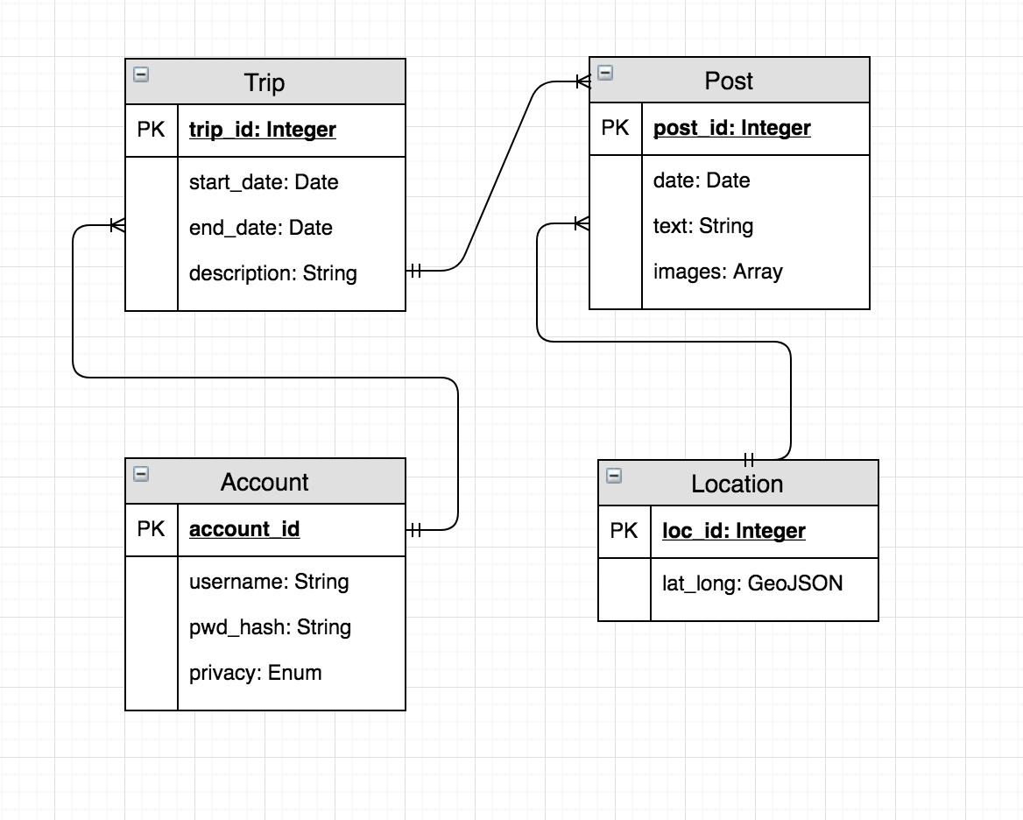

Database design for slightly expanded product:

